QD NetApp LSI fixit command

Apple had a power hit on the Array controller.

Tray 0 Volume 16 showed failed

**This command did not help**

root@mvp-svr-snfs-mdc04 stornext]# **SMcli -A**

Starting auto discovery.

Auto discovery operation successful.

SMcli completed successfully.

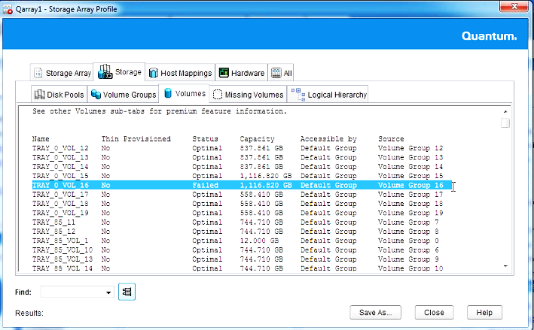

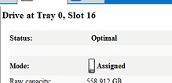Showed status Optimal here

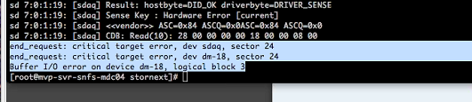

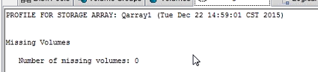

See next page for “fixit” command

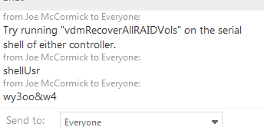

To get IP address of the Array controller in SANtricity Storage array profile > Hardware > Controllers

user **shellUsr** password **wy3oo&w4**

**“fixit command” vdmRecoverAllRAIDVols**

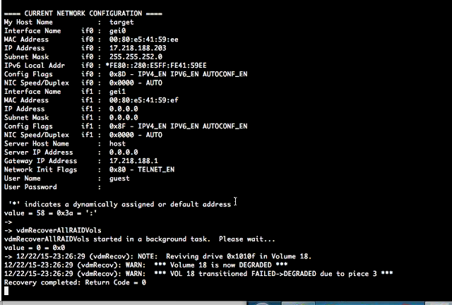

**can only run on this or later fw version**

// Firmware package version for Storage Array Qarray1 = **08.10.13.00**

// NVSRAM package version for Storage Array Qarray1 = N26X0-810834-DB3

VOL 16 was the problem volume but it “revived Volume 18

Log into QD array controller

