**StorNext / Xsan Playbook**

1. **PURPOSE**

Provide a tool to assist Support Engineers in supporting customers with mixed StorNext/Xsan environments. The goal for Support Engineers is to work with the customer to the point where we can exclude Quantum products as being the problem/contributor and ideally hand them some information they can take to Apple Support.

**2.0 SCOPE**  
 This procedure applies to any combination of StorNext/Xsan product deployments.

**3.0 REFERENCE DOCUMENTS**Quantum’s Compatibility Matrix – [Quantum.com](http://munich.quantum.com/products/xsan/data/SN_XSAN_Compatibility_Matrix.pdf)  
Apple’s Compatibility Matrix – [on Apple.com](http://support.apple.com/kb/HT1517)  
StorNext FX Resources – [on Quantum.com](http://www.quantum.com/products/software/stornextfx/index.aspx)  
StorNext Solutions for Apple Xsan – [on Quantum.com](http://www.quantum.com/solutions/apple/index.aspx)  
Xsan Support – [on Apple.com](https://www.apple.com/support/xsan/)  
Xsanity Forum – [click](http://xsanity.com/) here

**4.0 DEFINITIONS**StorNext – a collection of products produced, serviced and supported by Quantum  
Xsan – a product produced, serviced and supported by Apple   
StorNext & Xsan are completely interoperable with each other  
SRC0002 – Serial number assigned to Apple, which Apple Engineering can use to open SRs against, to get assistance from Quantum Development

**5.0 PROCEDURE OR WORK INSTRUCTION**This section lists useful interoperability information, typical scenarios we encounter, and other information which can help the Support Engineer in excluding Quantum products from being the problem and providing information the customer can take to Apple Support.

**5.1 Licensing**

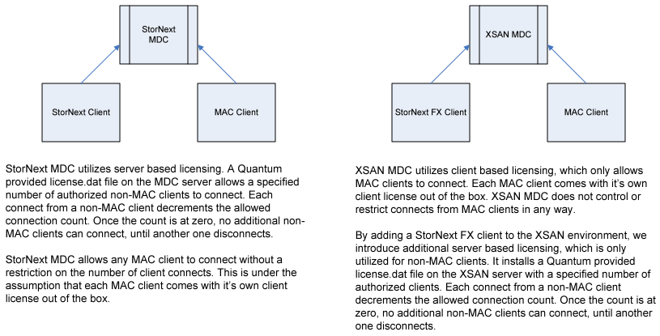

**5.2 Items to check when using StorNext MDC and Xsan clients**

See Apple Knowledgebase [article200132](http://support.apple.com/kb/HT200132)

**Notes:**

* A symptom of running ‘Case Insensitivity’ is a volume not being able to mount
* Spotlight search is not supported on StorNext volumes. Another way to access files outside of Spotlight is a program called [Found](https://www.foundapp.com/).

**5.3 Finder may not immediately display directory contents when accessing StorNext 4.x volumes**See Apple Knowledgebase [article 2000058](http://support.apple.com/kb/HT200058)

**Note:** File systems created under 3.x, even though 4.x is now installed, may not have RPL enabled

**5.4 Finder hangs**

See Apple Support Community [discussion](https://discussions.apple.com/message/24595268)

See Xsanity Forum [article](http://www.xsanity.com/forum/troubleshooting/xsan-221os106xsn41-finder-hangs-1067-patch-help)

**5.5 File naming problem in Finder**

If you see a file naming problem in Finder, try to reproduce it at the CLI level. If you can’t, you have a Finder problem, not a StorNext problem.

**5.6 Finder crashes**

See Xsanity Forum [article](http://www.xsanity.com/forum/troubleshooting/finder-crashes-after-xsan-finder-copy-apple-stumped)

**5.7 Volume becoming hidden**

See Apple Support Community [discussion](https://discussions.apple.com/thread/5794019?start=0&tstart=0)

**Issue:**

The volume had become hidden.  No root cause how it became hidden other than it only happened during high utilization and possibly high latencies.

Errors logged on mdc

Jul  1 15:31:26 t1mdc1 rsyslogd-2177: imuxsock lost 84 messages from pid 33571 due to rate-limiting

Jul  1 15:31:26 t1mdc1 kernel: CvOpenOnePath: Open Failed, disk <Nacho_0001> error 6 device </dev/mapper/mpathi>

/dev/mapper/mpathi [Quantum StorNext QX     H100] SNFS-EFI "Nacho_0001"Controller#: '208000C0FF1B172F' Serial#: '600C0FF0001B0CEC4A5A5B5301000000' Sectors: 76171856479. Sector Size: 512.  Maximum sectors: 76171856479

Note: “error 6 device” in this context is error EBusy, which means something is interfering with communication, such as a noisy port in the fabric.

**Resolution:**

Check on Mac client, if volumes are hidden/grayed out. To fix, run  
SetFile -a v /Volumes/VOLUMENAME

Doing an xattr doesn’t actually nuke this issue.

xattr -d com.apple.FinderInfo /Volumes/VOLUMENAME

**5.8 Using QLogic switches with Apple Fibre Channel Cards**See Apple Knowledgebase [article 1084](http://support.apple.com/kb/HT1084)

**5.9 Use case sensitive volumes for StorNext and pre-Lion clients**

See Apple article[support.apple.com/kb/HT200157](http://support.apple.com/kb/HT200157)

**5.10 Avoid using native extended attributes with StorNext clients**

See Apple article[support.apple.com/kb/HT200305](http://support.apple.com/kb/HT200305)

**5.11**

**Issue:**

Deleting files from directories in StorNext filesystem using Finder, but the files/folders do not show any changes

**Resolution:**

If this is a managed file system, this happens because the Trash folder isn't in the same Storage Manager policy as the files or folders being deleted. If there is only one policy, then you can put the Trash folder in that policy. If there are more than one policies, you have to remove the Trash folder and replace it with a link to /dev/null.

**5.12 Permission issues**?????

**5.13 Macs going to sleep**

Fixed in Mac OS 10.9.4