**QX-Series Playbook**

1. **PURPOSE**

Provide a tool to assist Support Engineers in supporting customers with QX-Series disk arrays. The goal of this document is to walk the Support Engineer through the troubleshooting process with the objective to do the Level I/II work required and then escalate to Dot Hill Level III team if we can’t resolve.

**2.0 SCOPE**  
This procedure applies all QX-Series and QXS-Series products.

**3.0 REFERENCE DOCUMENTS**QX-1200/2400 information on [CSweb](https://qsweb.quantum.com/wiki/tiki-index.php?page=StorNext%20QX-1200/2400)  
QX-1200/2400 documentation on [CSweb](https://qsweb.quantum.com/files_plugin_files1.php?mycategory=1929)  
QXS-1200/2400 information on [CSweb](https://qsweb.quantum.com/wiki/tiki-index.php?page=StorNext%20QXS-1200/2400)  
QXS-1200/2400 documentation on [CSweb](https://qsweb.quantum.com/files_plugin_files1.php?mycategory=1940)  
QX/QXS training courses in [StorageCare Learning](https://secure.quantum.com/QXpert/login.aspx)  
QX/QXS training presentation on [CSweb](https://quantum.app.box.com/s/j0eu94ob7fqhki7d89u5)  
QX/QXS Service Plan on [CSweb](http://qsweb.quantum.com/wiki/tiki-download_file.php?fileId=12067)

**4.0 DEFINITIONS**QX-Series – a Quantum branded product based on Dot Hill’s xxx disk array  
QXS-Series – a Quantum branded product based on Dot Hill’s xxx disk array

**5.0 PROCEDURE OR WORK INSTRUCTION  
  
5.1 Web Management**Open Web browser and go to the Web Based Interface (WBI) through  
http://<*IP address of management port*>  
  
**Note:** Default Username/Password = manage/manage!  
  
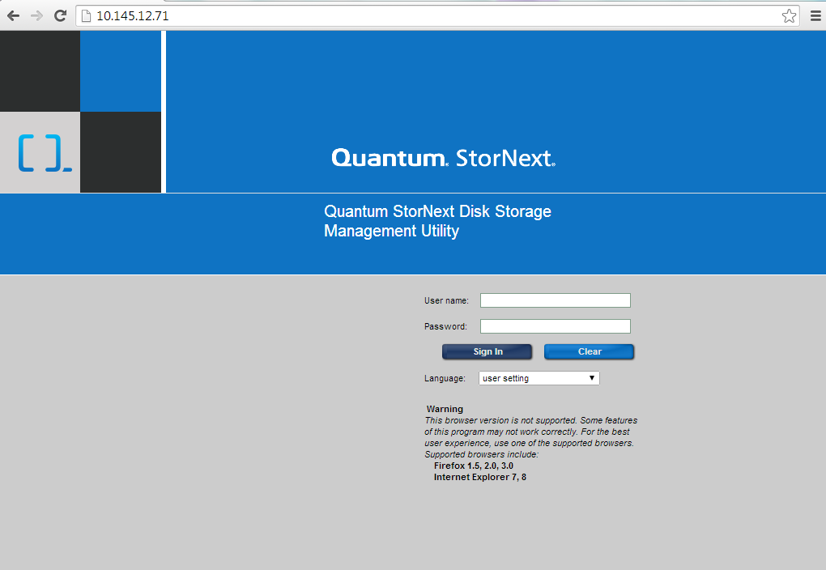  
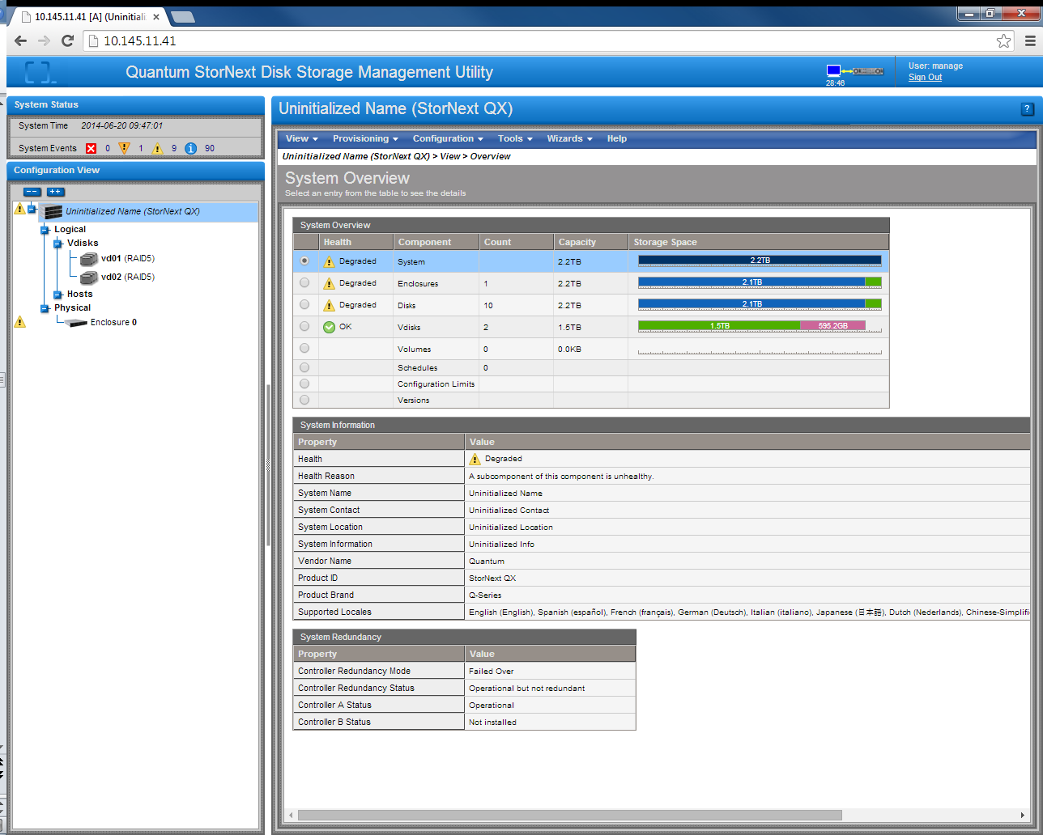

**5.2 Telnet and CLI Commands**Log into the command line interface through  
telnet < *IP address of management port*>  
 **Note:** Default Username/Password = manage/manage! (same as WBI)  
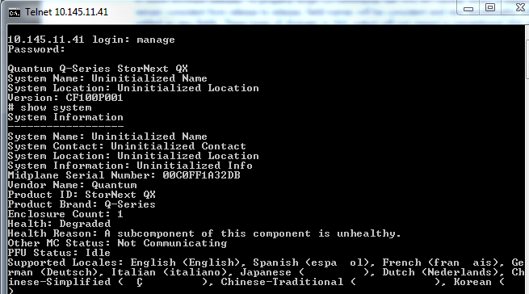QX/QXS CLI Reference Guide on [CSweb](http://qsweb.quantum.com/wiki/tiki-download_file.php?fileId=12470)

**5.3 How to Identify an Array Serial Number**Quantum uses the midplane serial number to identify arrays and track them in Oracle. The midplane serial number can be identified through the WBI and through the logs.

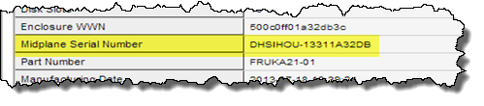 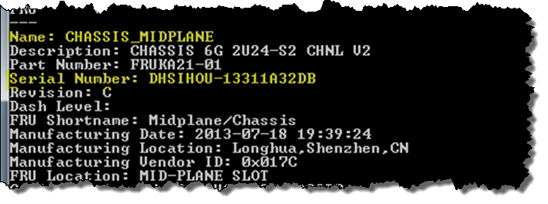

Serial numbers start with either QTMCHOU or DHSIHOU.

QTMCHOU – These are Quantum branded GA units.  
DHSIHOU – These are pre-GA units, which are Dot Hill branded and were delivered to Quantum customers prior to Quantum branded units being generally available.

**Note:** Quantum stocked spare parts are fully compatible with both variations.

**5.4 How to Check Firmware Versions**Controller firmware versions can be checked using the CLI command show version.

**5.5 Troubleshooting**Analyze array logs and perform any necessary actions you conclude from the analysis (drive replacement, reseating of controller, controller replacement, etc).  
  
**5.6 Escalation to Dot Hill**  
 Escalate to Dot Hill, if your troubleshooting conclusions and activities do not resolve the problem. Avoid escalations that simply result in suggestions from Dot Hill to replace a drive, reseat a controller, or replace a controller.  
  
To escalate to Dot Hill, follow the escalation procedure described in section 7.1 of the [Service Plan](http://qsweb.quantum.com/wiki/tiki-download_file.php?fileId=12067).

**Note:** Before you can open cases with Dot Hill, you need to register for an account, as described in section 7.1.1 of the [Service Plan](http://qsweb.quantum.com/wiki/tiki-download_file.php?fileId=12067).

**5.7 Dot Hill Support Site Information**Browse to <http://support.dothill.com> and log in  
To create a new support case, select “Create an Issue”  
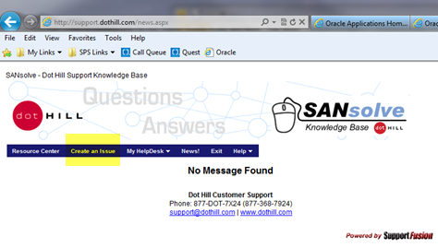  
  
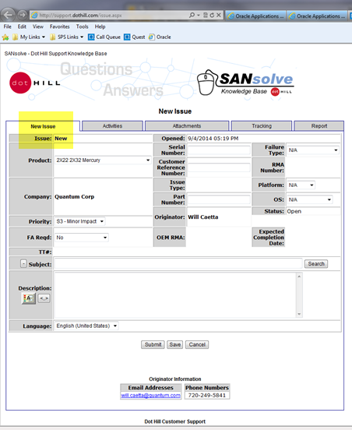

To access an open case, select “My HelpDesk -> My Issues List”  
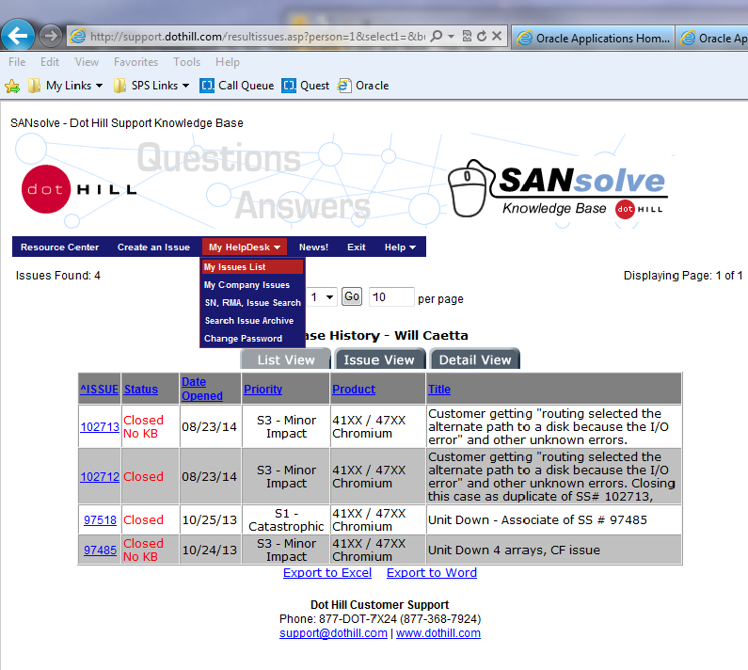  
  
  
**General Ticket Information**  
In the issues list, select the case to view. You will note five tabs across the top of the case log. These tabs hold all information for that case. These are used for recording activity updates, uploading attachments, tracking info, and reporting.  
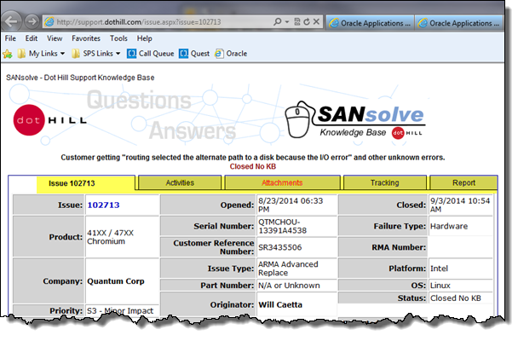

**Support Personnel Communications**  
When working with a Dot Hill Support Engineer, you should regularly receive email updates from them. When getting and responding to Dot Hill Support, always Reply to All. Typically the email will come from the Engineer who’s assigned the case, and be addressed from “Dot Hill Customer Care <[support@dothill.com](mailto:support@dothill.com)>” . Also note, all emails sent to and from [support@dothill.com](mailto:support@dothill.com) are automatically entered into the notes of the case.

**Accessing Documentation and Knowledgebase**  
Under the “Resource” tab on the main support page after you Login is a set of Search blocks that will search various documents and downloads in the Customer Resource Center. This [Link](https://crc.dothill.com/portal) will take you to the same page, outside of the Support Portal.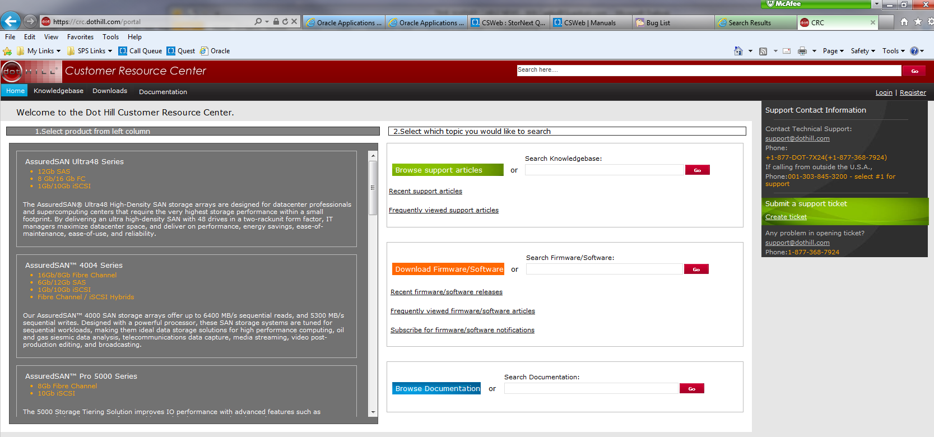  
  
**Firmware Bugs/Issues per Version**  
From the Resources page, select “Download Firmware / Software” and search for “Release Notes”. It will show each firmware version. Select the “more” tab at the bottom right of the block of the version you are looking at and it will list the PDF documents related to that version. The Release Notes PDF lists all enhancements and bugs fixed in that version.  
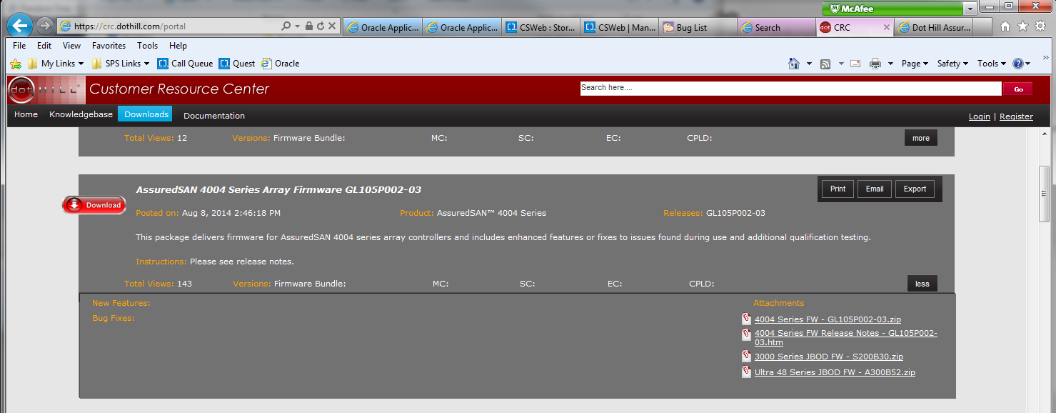  
  
**5.8 Firmware Auto-Update Settings  
  
5.9 Firmware Upgrade/Downgrade**  
Use CLI to ftp connect to the array. Follow the instructions which are automatically displayed in the terminal screen after the ftp connection has been established.

**5.10 Replacing Disk Drives  
  
5.11 Logs**