Memory Management on the DXi
Part 1 by Greg S. Lopp
There have been a great many escalations relating to memory management issues on the DXi. In order to constrain and provide a frame work for discussion about memory issues, this paper will attempt to cover the concepts and requirements for memory management in a multi-processor environment, used as a product base for the DXi family of products. Starting with the basic components and working towards a better understanding of the memory management subsystem.
To begin a discussion of memory management we need to break this down into its basic components the way I learned them years ago. In a multi-processing environment, operating systems share available resources effectively among all the processes running on a system. The memory, CPU, and I/O subsystem are all resources. Although today’s CPU’s have large cache memory available on chip, the cache memory is primarily used as cache to keep the thread queues full. To state in a simpler way, L2/L3 cache memory acts as pre-fetch cache so the nanosecond CPU’s cycles are not kept idle waiting on access to main memory.
Main memory and the Memory Management Policy (MMP) should be dynamically responding to how memory is used by processes. To phrase another way, memory management must be directly related to how the processes memory requirements are used in a system. Generic MMP is used for systems with many small processes, that have a short life span. Processes that have large memory requirements, that require memory resident in large continuous chunks, require a different MMP policy.
The Berkley Software Distribution (BSD) is another UNIX based operating system. Computer systems from 20 years ago did not have the large volumes of memory like today. The Memory Management Policy in BSD was designed for tighter memory constraints, which usually attempt to optimize the number of runable processes that are resident in main memory. This resulted in the original architecture of processes and memory as used in virtual machines. This opens the door to what is termed the virtual address space. The virtual address space is a range of addresses that a process can address independently of real physical memory available on the system hardware. The DXi system physical memory ranges from 48 Gigabyte to 256 Gigabyte of physical memory. The processes reference to a Virtual Address Space is translated into a physical memory address. Memory is broken into segments, which are managed by the MMP and allocated to processes on a demand basis. Well that was a leap, getting ahead of my self..
In summary, a compiler generates code for a virtual address space. The memory management translates the virtual address to a physical address. A program becomes a process when it is allocated memory for Text(Instructions, text), Data(memory data), Stack(local routines, structures); This named process can have multiple executions of itself on a single system, at the same time, Only because the memory management translates each process virtual address to a different physical memory address .
The concept of virtual memory is stated as the MMP allows the range of addresses to be provided to a processes, independent of the physical memory allocation on a system. Virtual memory can be implemented in many ways, software or hardware based. This line is now rather fuzzy, due to the technology changes in virtualization. So staying with standard terminology, the physical memory is broken into segments size units. The segments of physical memory are presented to processes by the virtual memory address translation to the segments in physical memory. This address translation to physical memory and paging algorithms shall not be covered, but left as magic concept, for the relief of the readers. For Deeper Dive, start with reference [Organick, 1975; Coffman and Denning, 1973] with a cup of tea in hand.
Each segment of physical memory is marked as resident or non-resident in main memory. Why do you need to know this? Simply this is the basis for moving memory in and out of SWAP. The DXi typical has about 16 gigabyte of SWAP. Now 16 gigabyte sounds like a lot of SWAP. But the processes like the blockpool start at 40 gigabyte, to 60 gigabyte without any coffee. Four times the available SWAP space. So what is SWAP ?
The swapper process is the only process to swap processes in and out of memory to SWAP devices. The swapper runs in an infinite loop, and is scheduled by the kernel and spends most of its run life sleeping. For the swapper to swap a process out, all processes in the process table are examined, the heuristic in System V is the process nice value, and the time the process has been in memory. The down side is that it takes time and is considered an expensive process to SWAP. Obviously this means SWAP is supported on a slower speed device, like a spinning disk, and for some reason is of limited size on most systems. To solve these problems Demand Paging (DP) allows process with large memory requirements to page memory from virtual pages to SWAP. Stated another way, demand paging allows say 4 gigabyte of 50 gigabyte process to be paged to the SWAP area, freeing up 4 gigabyte of free memory.
Lets look at a process in a Demand Paging Kernel. As a process (Text, Data, Stack) starts up, It needs very little memory resident for access. Some deployments of UNIX can start a process with as little as one page. Now the process must be able to reach segment of its address space on demand. The Kernel must create pages in virtual memory on demand, for any reference to Text, Data, Stack. As a processes runs, its accesses pages of memory. Each page then ages from the last touched time mark. Older pages can now be marked eligible to be paged out to Swap. When the process attempts to touch a page that has been paged to Swap, (called a page fault) this traps to the kernel which schedules to bring the page back in to memory. So, yes still a expensive process, that requires the kernel to intervene.
This was a lot of background territory, necessary to set the foundation of looking at the DXi memory usage. If you are still with me, let’s look at some color graphs from a DXi DATA of the memory page. Additional will look at some differences between time events from the memwatch.log collected on the system. The basic concept of memwatch is a collection of processes that record the system memory use, Simply which processes have allocations of memory.
The start of the event is a process being allocated additional pages of memory from the physical memory pool of 64 gigabytes. Below we see memory used increase as the allocation is done. Thank you MMP you are behaving as designed. What happens to Freemem ?
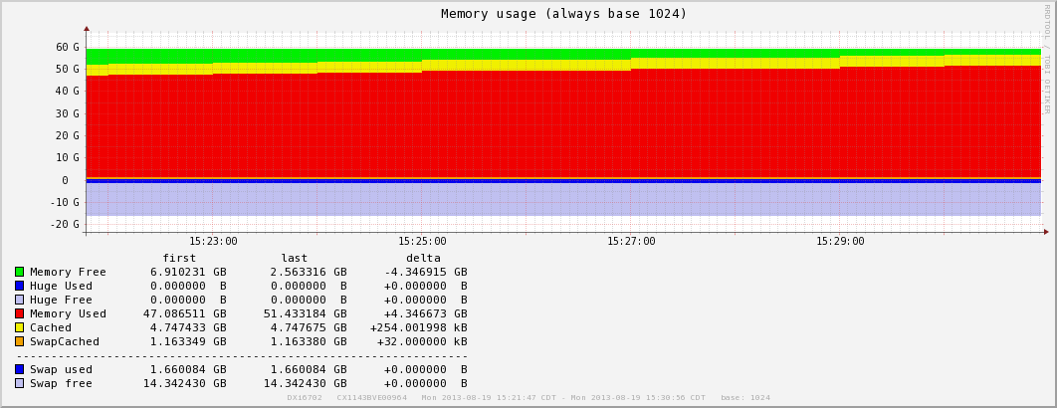

Who was this allocation of memory delivered to ?, the graphic above does not list the owner. For this we must look at the memwatch logs on the system. Hmm, jumping fast here so stay with me… In ./app-info/memwatch.log .* is a set of time stamped process data. Yes we will cover this in more detail later, but for now lets look at what is of real interest in memwatch.log at the time marks in the graph above. Below is the differ output removing duplicate lines and noise. First the time marks:
< Mon Aug 19 15:21:57 CDT 2013
> Mon Aug 19 15:26:58 CDT 2013
Then the differences in memory, physical memory, notice MemFree dropping to 4756372 kB this tracks the graphic above.
< MemFree: 7246108 kB
> MemFree: 4756372 kB
Next the differences in Memory used listed by processes from the unix command “top” is listed. The RES is Resident memory, the VIRT is Virtual memory. So the blockpool is gaining additional Resident memory usage at time mark . Aug 19 15:26:58 CDT 2013
PID USER PR NI VIRT RES SHR S %CPU %MEM TIME+ COMMAND
< 32313 root 15 0 3513m 2.6g 2.5g S 0.0 4.4 4913:21 ostd
> 32313 root 15 0 3513m 2.6g 2.5g S 3.9 4.4 4913:37 ostd
< 30868 root 15 0 3716m 2.7g 2.5g S 0.0 4.5 619:50.58 bpwd
> 30868 root 15 0 3716m 2.7g 2.5g S 0.0 4.5 619:53.83 bpwd
< 25779 root 15 0 52.5g 47g 2.5g S 0.0 80.2 14282:08 blockpool
> 25779 root 15 0 52.3g 49g 2.5g S 41.2 84.2 14283:36 blockpool
< 3654 root 15 0 517m 37m 13m S 0.0 0.1 6:09.12 webguid
> 3654 root 15 0 517m 37m 13m S 0.0 0.1 6:09.14 webguid

Overall a pretty normal operation for the DXi system, when ingest is increasing and The customer is reading from the blockpool at the same time. Next we will see what happens when the FreeMem is very low, and suspected other processes need to run, and as expected need memory allocated. Remember each process needs some memory to run. The MMP is responsible of balancing the memory requirements for the System, attempting to meet the demand for each process. I realize this is contrary to popular belief that the blockpool controls the system. The blockpool consumes resources from the system, but each resource is granted by the UNIX operating systems as a whole. So lets look at the next event.
Note that the time marks in memwatch.log are 5 long minutes apart. That is 300000 milliseconds. Process life time can be as short as a thousand milliseconds, Systems logs track to the second mark. So why do we not run memwatch more often, Simple, the DXi memwatch consumes resources from the system. Its design is of a trending tool.
Now lets look a bit later at memwatch.log top data for middle of swap event. This shows swap on blockpool Resident memory 52 gigabytes to 48 gigabytes. New memory low of 330148, Interesting Cached behavior.
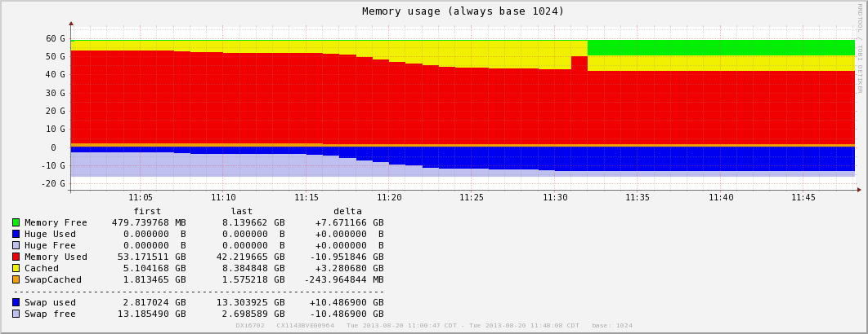

Again from the memwatch.log file. Looking at time marks below, with relation to graph above. System Memory MemFree dropping still, Swap increase by 4 GB. Dropping to 8423568 kB The questions is who paged memory ? So below we see the blockpool giving up 4 gigabyte to Swap.
< Tue Aug 20 11:14:25 CDT 2013
> Tue Aug 20 11:19:26 CDT 2013
< MemFree: 330148 kB
> MemFree: 300168 kB
< SwapFree: 12685732 kB
> SwapFree: 8423568 kB
PID USER PR NI VIRT RES SHR S %CPU %MEM TIME+ COMMAND
< 30868 root 15 0 3716m 2.7g 2.5g S 0.0 4.5 643:50.53 bpwd
> 30868 root 15 0 3716m 2.6g 2.5g S 0.0 4.5 643:50.54 bpwd
< 25779 root 15 0 54.7g 52g 2.5g S 0.0 89.3 14918:20 blockpool
> 25779 root 15 0 54.7g 48g 2.5g S 0.0 82.6 14918:20 blockpool
The real Question is what triggered this behavior. The blockpool is a process that is very memory dependant on large blocks of memory. Above the blockpool is being forced to Page memory to the reserved SWAP. Between 11:14 and 11:19 blockpool Resident memory drops to 48Gigabytes. What caused this behavior is subject to speculation. Remember the UNIX operating system is a time slice based operating system.
The logs do not document at a fine grain level the event, but provide a window time stamped between Tue Aug 20 11:14:25 CDT 2013 and Tue Aug 20 11:19:26 CDT 2013. Some possibilities, most UNIX commands have a memory limit of 4 gigabytes of memory allocation. Another possibility, remember the blockpool has the most memory under allocation, and memory pages are tagged with last touched time. Now we have not covered process scheduling yet, But If the process is ready to run, then the operating system, shall allocate requested memory for a process. In a crunch, the largest memory process (read blockpool) will be requested to release pages by transferring the pages to SWAP storage. The Memory Management Policy shall page out Resident physical pages to SWAP storage freeing up physical pages for the next process.
“Operational Level of memory for the UNIX Operating System” is a prime concern. Linux has brought its own flavor of memory management into the picture. The processes which consume large blocks of memory, done for speed, require special Memory Management Policy to balance system memory operations to avoid this type of memory starvation as seen in the graph above.
Of Course, there is the other well used option. Double the system memory pool, to cover the problem!
Having laid the ground work for common discussion, where are we heading. Part 2 shall take a deeper look at the Linux Memory Management, Process Address Space, and Page Caching to explain the Linux handling of memory.
Tech Tip passed down from DXi Development: Memwatch logs files roll and are compressed in the collect log. To save more memwatch log files, make the following changes. Even with the 5 min interval, the files are small, and a deeper trending history can really help solve some mysteries. They are 8MB each, so a larger number like say 10 or 20 will not overload the file system.
# vi /opt/DXi/scripts/memwatch.sh
Find this section at the top of the file (line 22 in 2.3 code)
$LOGFILE {
rotate 4
compress
}
Change the 4 to how many ever files you want to save, maybe 10 to 20 depending on what you are chasing. Then you need to stop and start memwatch:
# /etc/init.d/memwatch stop
# /etc/init.d/memwatch start

Written by Greg S. Lopp for Quantum Corp.
Reference material: for folks looking to expand their own memory.
UNIX System, Bell Laboratories Jan 1983;
4.3 BSD UNIX Operating System, 1989;
Design UNIX Operating System V5R2, 1986;
Modern Operating Systems, 1992;
The Magic Garden Explained; Internals of the Unix System V R4, 1994;
Understanding the LINUX KERNEL, Second Edition 2002;
Linux kernel Development, third Edition 2010;
AT&T System V R3 Course, 1986;
Solaris Internals, Operating Systems Course, 1992;

Trademark Information:
UNIX is a registered trademark of AT&T, Bell Laboratories.
SPARC is a trademark of Sun Microsystems.

