## Lattus Multi-hop Upgrade

Objectives

Practice upgrading your Lattus system. In these steps, you will upgrade from version 3.1.4 to version 3.3.1. Upgrading to Lattus 3.3.1 is a two-step process--the first step is to upgrade to Lattus 3.2.1, and then upgrade from there to Lattus 3.3.1.

You will complete the following tasks in this lab:

* Identify where to download the latest version of Lattus software
* Upgrade Lattus from version 3.1.4 to 3.2.1
* Upgrade Lattus from version 3.2.1 to 3.3.1

### Move Lattus Software to the Management Controller Node

This has already been done for you. The 3.2.1 and 3.3.1 Lattus upgrade packages are already in the /root directory of Controller1.

### Upgrade Lattus from 3.1.4 to 3.2.1

To upgrade Lattus from 3.1.4 to 3.2.1:

1. Using public IP address for Controller1, open PuTTY and access the node.

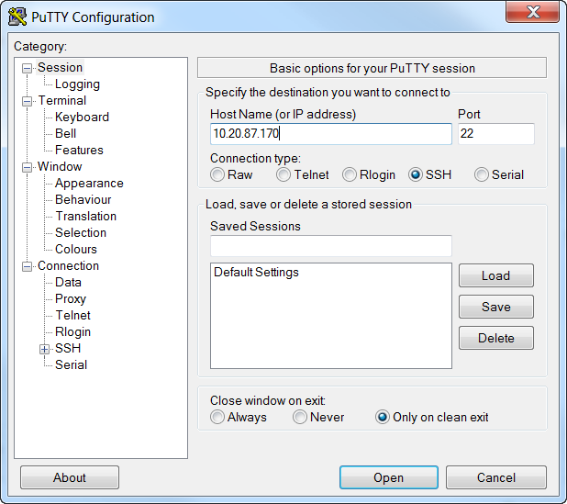

1. Use the following credentials to log into Controller1:
   * Username: **root**
   * Password: **rooter**

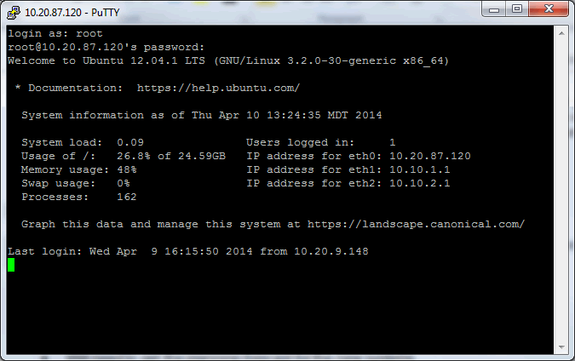

1. Type **0** and the press **Enter** to exit out of the OSMI menu. The following prompt appears.

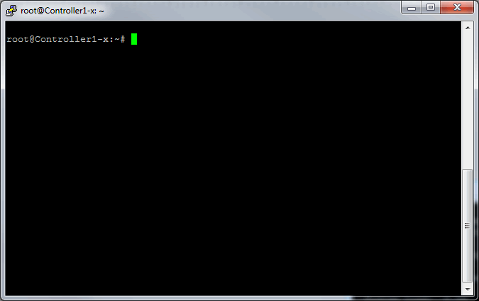

1. Type **qshell** and press **Enter**.

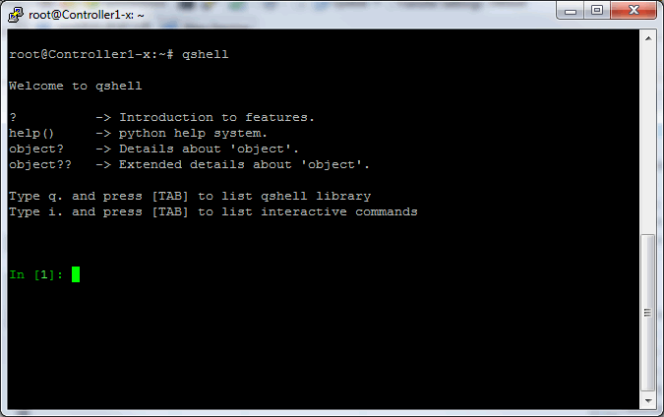

1. Run a health check on your environment by running this qshell command:

**q.lattus.healthCheck()**

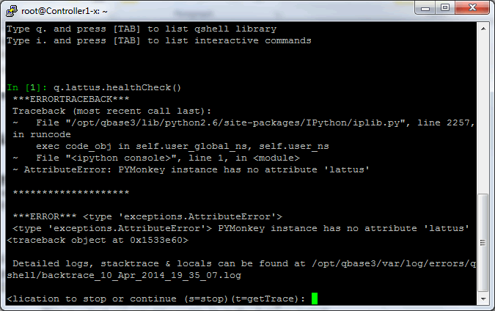

**noteV2Note**: Healthcheck may report errors. These errors are due to the virtual environment and can be ignored for this lab.

1. Type **quit()** and press **Enter** to exit qshell.
2. Make sure that you are in the **/root** directory and run the following command to extract the upgrade package:

**tar xzf Lattus_3.2.1.tgz -C /opt/qbase3/**

1. Open a screen session on Controller1:

**screen -S 3.2.1.upgrade**

1. Execute the following commands to upgrade Lattus:

**cd /opt/qbase3/utils/**

**./apply_package.py -d -r -p Lattus_3.2.1**

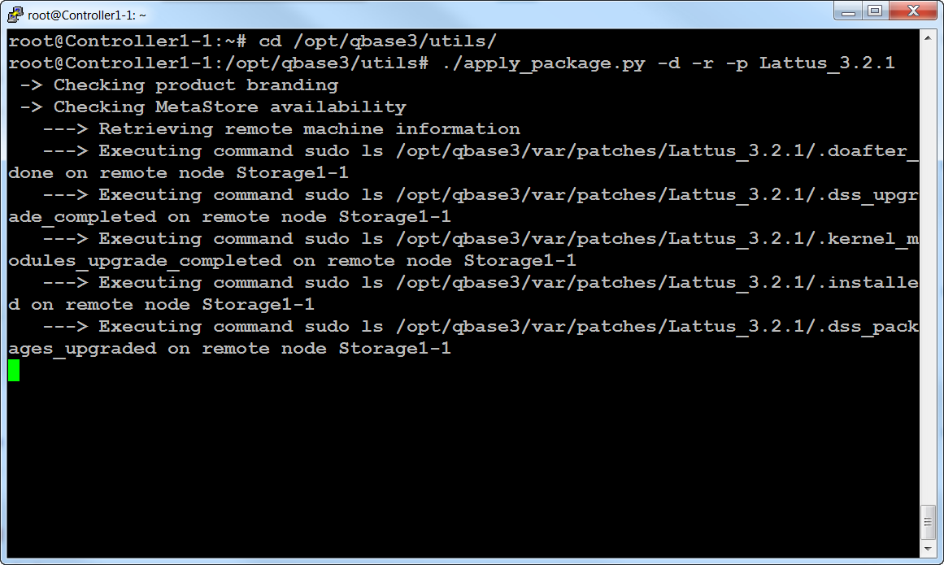

A “*** DONE ***” message appears when the upgrade is complete.

1. Leave the PuTTY session open and continue with the Upgrade Lattus from 3.2.1 to 3.3.1 procedure.

### Upgrade Lattus from 3.2.1 to 3.3.1

To upgrade Lattus from 3.2.1 to 3.3.1:

1. Access your PuTTY session and log in to your Controller1, if necessary.
2. Type **qshell** and press **Enter**.
3. Run a health check on your environment by running this qshell command:

**q.lattus.healthCheck()**

**noteV2Note**: Again, Healthcheck may report errors. These errors are due to the virtual environment and can be ignored.

1. Type **quit()** and press **Enter** to exit qshell.
2. Make sure that you are in the **/root** directory and run the following command to extract the upgrade package:

**tar xzf Lattus_3.3.1.tgz -C /opt/qbase3/**

1. Open a screen session on the management node:

**screen -S 3.3.1.upgrade**

1. Execute the following commands to upgrade Lattus:

**cd /opt/qbase3/utils/**

**./apply_package.py -d -r -p Lattus_3.3.1**

The upgrade process begins, as shown in the following example.

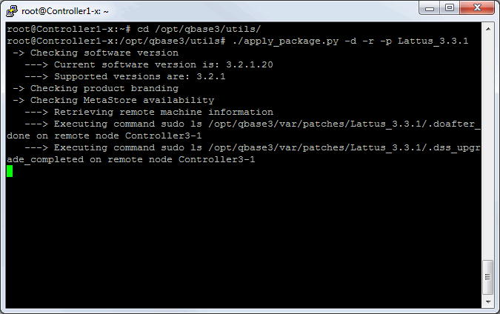

The initial upgrade takes approximately 30 minutes to complete. When complete, you will see “done”, as shown below.

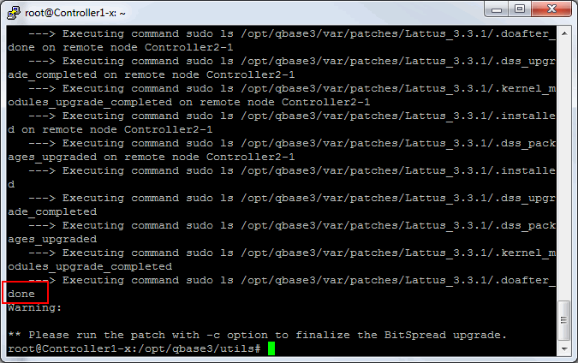

1. After the initial upgrade has finished, complete the upgrade by running the following commands:

**cd /opt/qbase3/utils/**

**./apply_package.py -c -p Lattus_3.3.1**

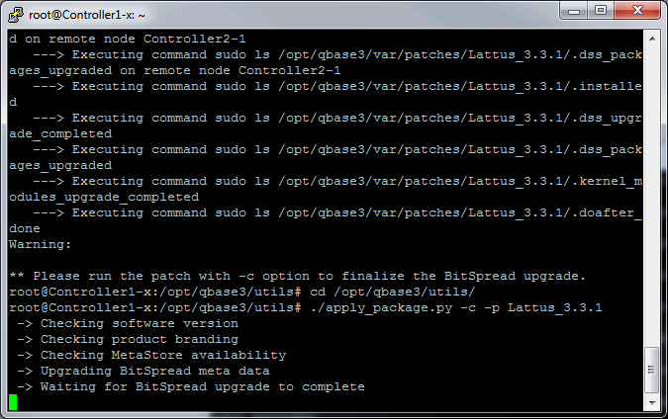

A “*** DONE ***” message appears when the upgrade is complete.

1. Once the upgrade completes, close the PuTTY session and log out.