A drive that posts an Impending Drive Failure (SMART) error will not set the blue ready to service LED until the failing threshold is crossed.

I have not seen any drive failures on the Dell R910 or MD1220.

The method to detect a pending failure is to go to log into the GUI. Select the Status option and highlight the specific controller you want to examine. Controller A0 is for the R910 in-built drives and Controllers A1or A2 are for the MD1220 drives.

Once you select the controller, select the drive option. All of the drives and the Status will be displayed. See the two screen shots below.

Controller A0 (13 drives):

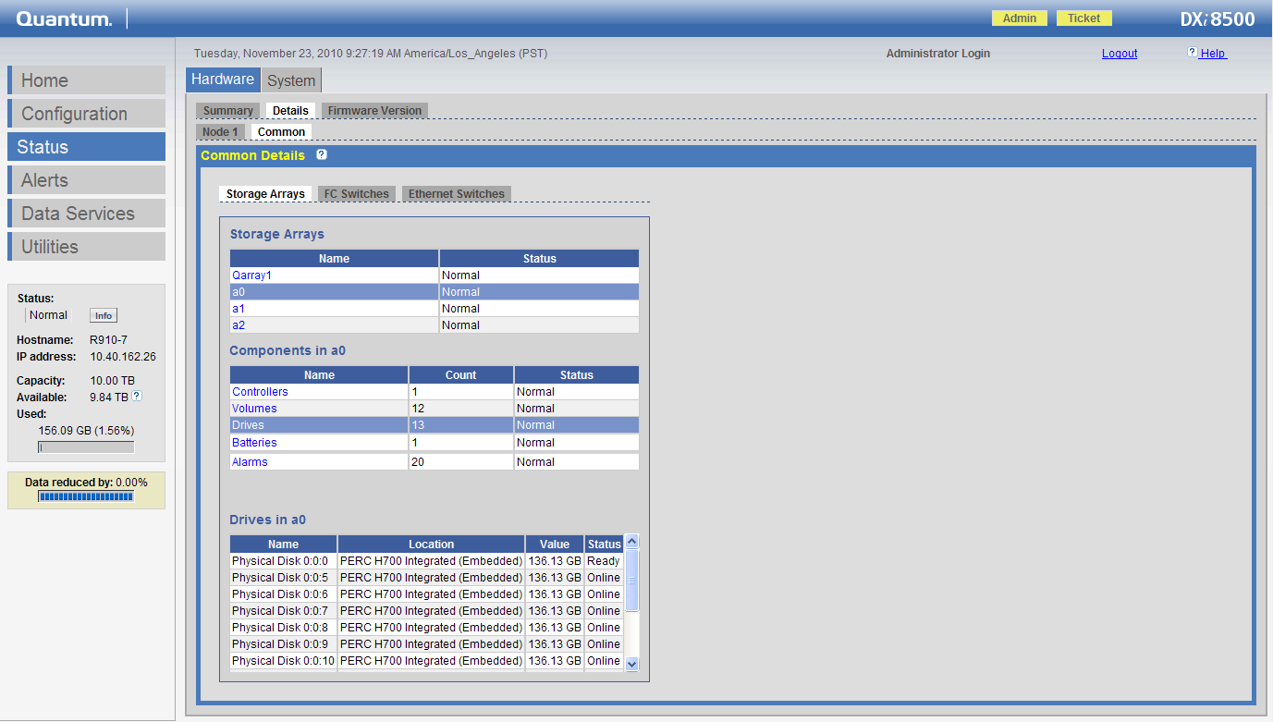

Controller A0 or A1 (17 drives)
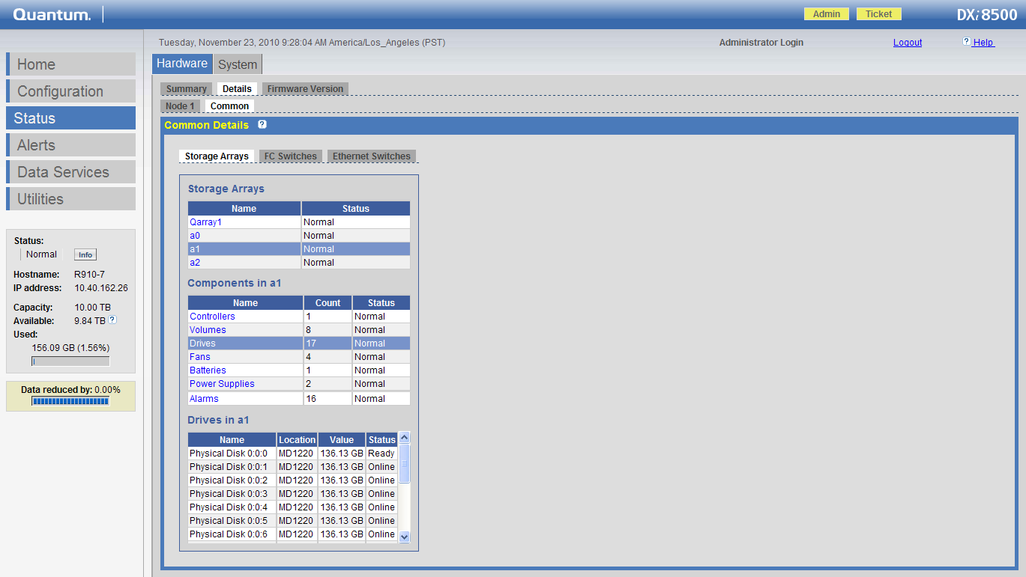

The status of the drives in the LSI arrays/JBODS can be found through Santricity. Logon to the system via the iDRAC6 port. Execute the “Virtual Console” and login. Execute startx & to start Santricity. In the Devices tab find the Qarray that Needs Attention (see screen shot below). It’s Qarray9.

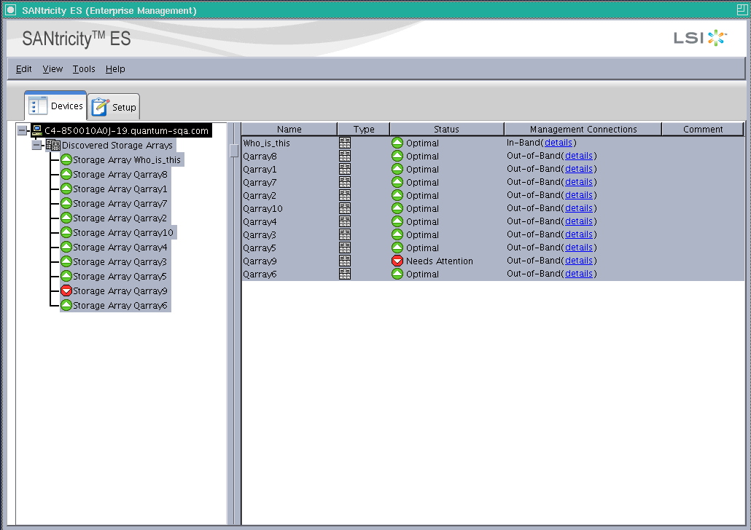
Right click on the Storage Array Qarray9 and select Manage Storage Array. The drive that needs attention is in Tray 85, Slot 7. It’s failing for an Impending Failure and no blue service LED is set on the drive. SMART analysis expects this drive to fail sometime in the future. This drive should be replaced. You can set the locate LED by placing the mouse over the drive with the yellow diamond, right clicking the mouse, selecting locate and then drive. This will turn on the blue LED to show which drive to replace. You have to shut the locate function off when complete.

The following screen shot shows an Impending Failure on the Slot 7 drive in LSI Qarray9 Tray85.

