HP Library and Tape Tools (LTT) Utility usage for gathering drive logs

Purpose:

This documents usage of the HP Library and Tape Tools utility for gathering drive logs in a typical HP LTO deployment. This example uses a Windows version. The document also defines which Drive and Media tests to run, what data to collect and procedures for collecting the data along with examples.

Prerequisites:

1). The host system requires access to tape drives.
2). HP LTT utility installed. This utility can be obtained from the HP Software/Device Driver download webpage.
3). A known good test tape (Some tests are data destructive).
4). Backup Applications services may need to be halted to prevent device contention

NOTE: If using LTT to downgrade FW, the most current Engineering password will be needed to be obtained from the Drive Engineering Team.

Procedure:

1). Scan for devices

NOTE: It may be required to stop Backup Application Services to allow LTT access to the devices. If an error similar to “Cannot Open Device” or “Device Not Found” occurs and devices are clearly detected at the OS/HBA level, there may be a Backup application reserving and locking out LTT access to the device.

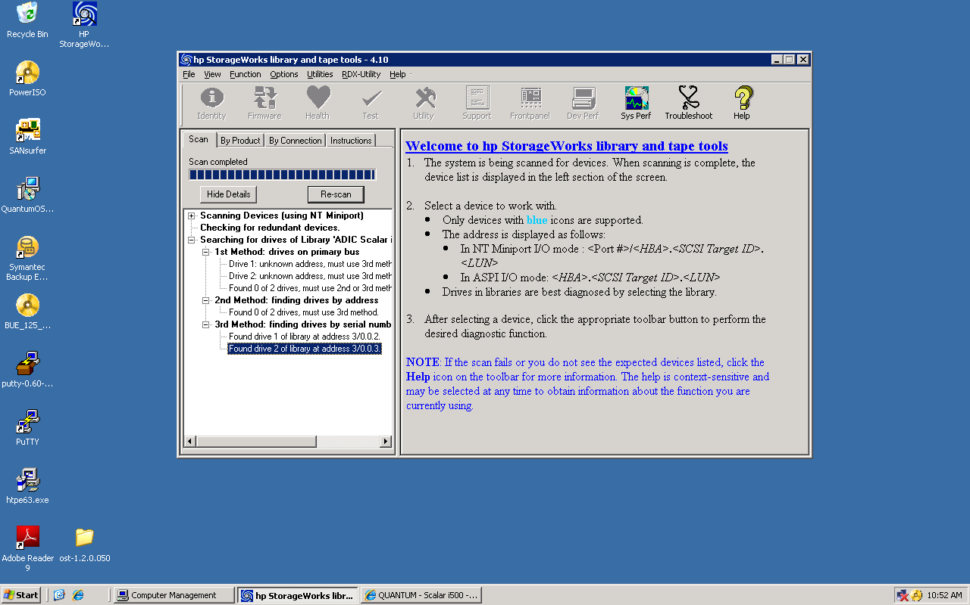

2). Select target drive from which log is to be captured

Select “By Product” tab and highlight the tape drive targeted for log capture

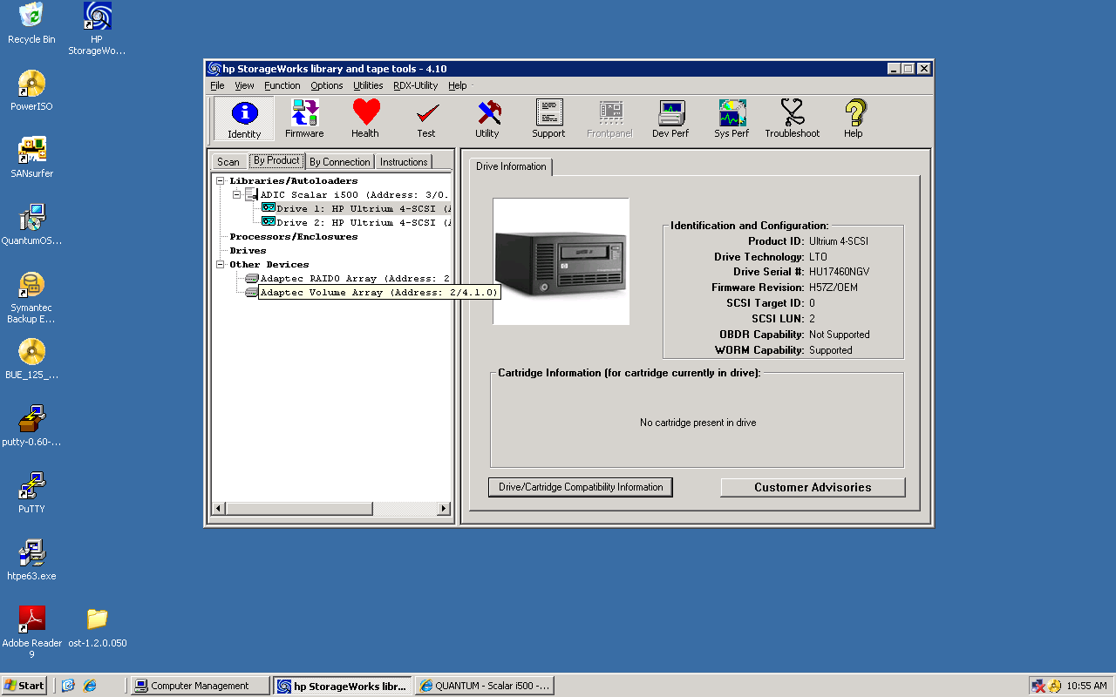

3). Drive Assessment and Media Assessment Testing

Select the “Test” tab. This will present several testing options from the “Test Group” pull down menu. Selecting each respective test will present a description of the tests and details specific to what actions may be required (ex. install test tape, confirming test is destructive..etc).

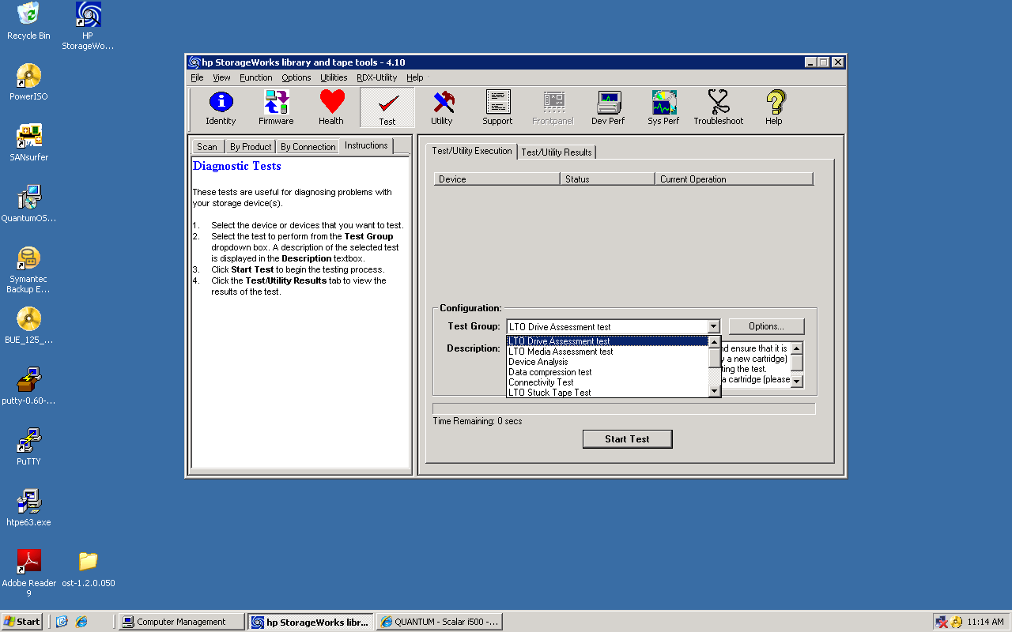

The Quantum Drive Engineering Team has defined the following tests to be executed as a minimum whenever collecting drive logs for escalation/analysis:

LTO Drive Assessement Test overview
This test will check the functionality of your LTO Drive, and ensure that it is working correctly. Please load a data cartridge (preferably a new cartridge) and set the 'Allow overwrite' test option to true before starting the test.

WARNING: This test will erase any data already on your data cartridge (please ensure the data cartridge is not write protected).

LTO Media Assessement Test overview
This test will check the functionality of your LTO Data Cartridge, and ensure that it is working correctly. Please load the required cartridge before starting the test. Before running this test, please ensure that the drives operation has been checked using the LTO Drive Assessment Test (the test will need to have passed recently with sufficient margin for the results of this test to be valid). The default test options will perform a READ ONLY test to assess the quality of the data already backed up on the data cartridge, and not the quality of the media. To perform the full Media Assessment Test, please set the Allow Overwrite test option to TRUE before starting the test.

WARNING: Running the test with the Allow Overwrite test option set will erase any data already on your data cartridge (please ensure the data cartridge is not write protected).

LTO Stuck Tape Test overview (Optional: Only if there is a stuck tape scenario)
This test will try to determine if the cartridge in the drive is physically stuck, or if it can be recovered/unloaded. This test should only be run if you believe that the currently loaded cartridge is STUCK.

3a). Drive Assessment Test

With a drive loaded with a scratch cartridge, select the “Test” and then “Test/Utility” tab option from the HP LTT Utility GUI.

Select “Drive Assessment Test” from the “Test Group” pull down menu.

Click “Start Test” button

NOTE: Drive must be loaded with a tape cartridge
NOTE: Drive Assessement Test is data destructive

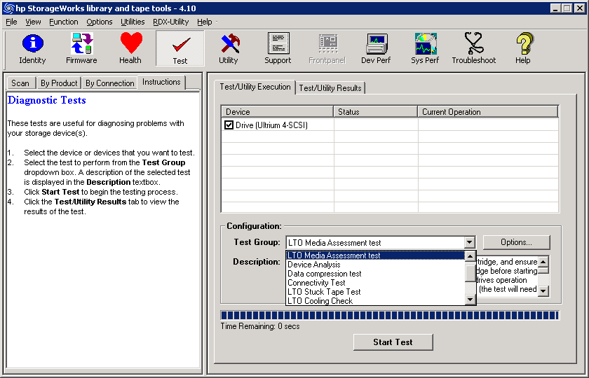

Several iterations of testing will prompt multiple messages similar to below as the test progresses to completion (ignore).

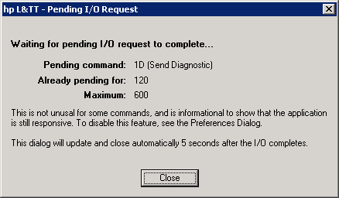

Testing will complete in approximately 15-20 minutes.

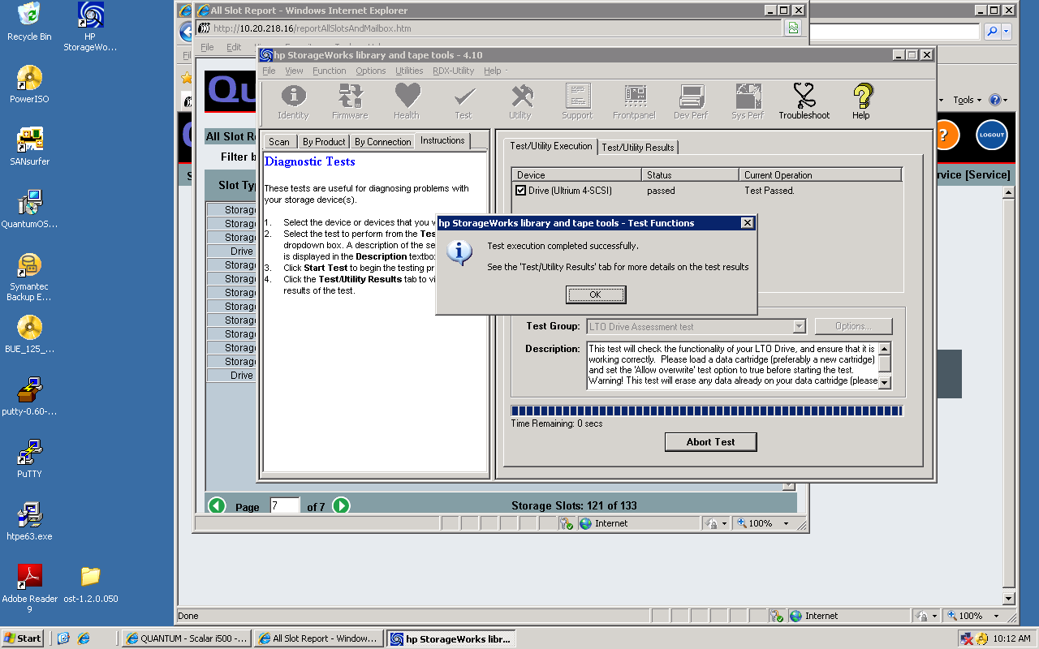

View results (Pass/Fail) from GUI.

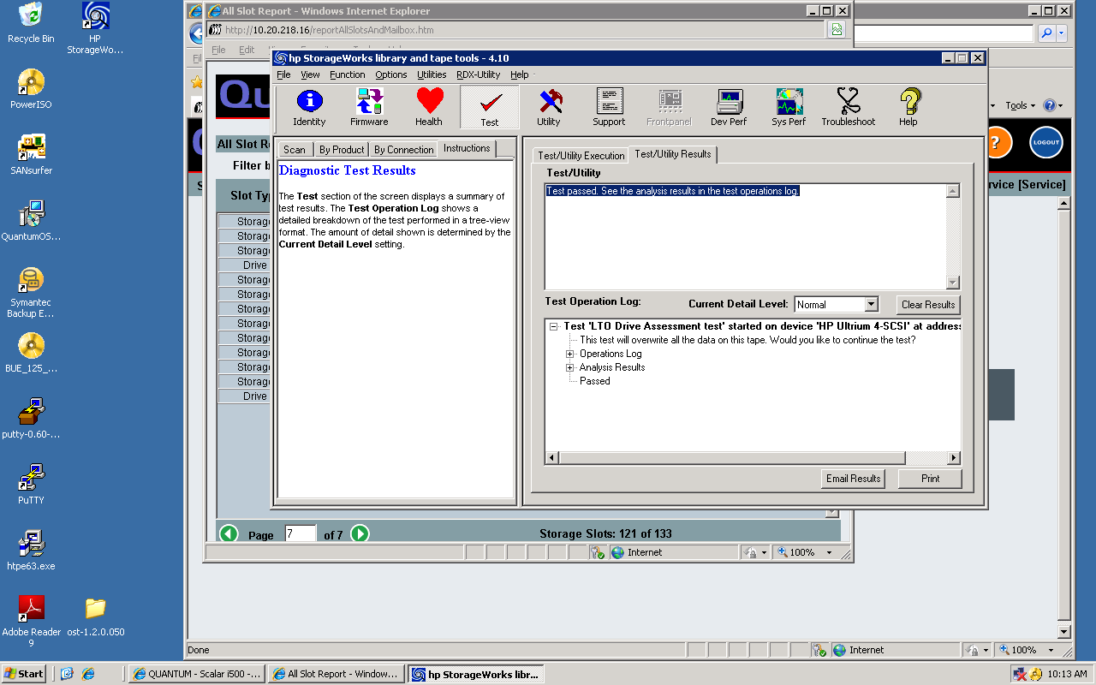

To gather test from the test results, Right click on Test operation log, select “copy Tree” to past test results into an email or document for archive.

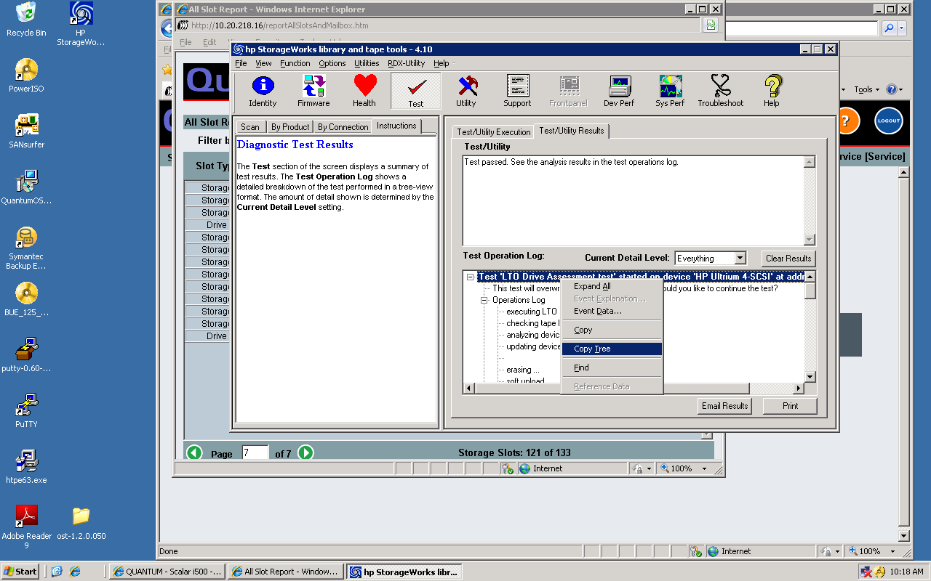

Here is an example output of the Drive Assessement test results:

|__ Test 'LTO Drive Assessment test' started on device 'HP Ultrium 4-SCSI' at address '3/0.0.2'
|__ This test will overwrite all the data on this tape. Would you like to continue the test?
|__ Operations Log
| |__ executing LTO Drive Assessment Test...
| |__ checking tape load ...
| |__ analyzing device data...
| |__ updating device writeback data...
| |__
| |__ erasing ...
| |__ soft unload ...
| |__ loading ...
| |__ writing wrap 4 ...
| |__ writing bottom wrap ...
| |__ writing top wrap ...
| |__ writing wrap 1 ...
| |__ soft unload ...
| |__ loading ...
| |__ erasing ...
| |__ rewinding ...
| |__ Test Passed.
|__ Analysis Results
| |__ LTO Drive Assessment Test, version V05.02.2010
| |__ Test run: Mon May 10 09:53:49 2010
| |__ Drive serial number: HU17460NGV
| |__ Data Cartridge Information:
| |__ Vendor: FUJIFILM
| |__ Format: LTO-4
| |__ Serial Number: 076H115292
| |__ Barcode: Unknown
| |__ ANALYSIS OF HISTORICAL INFORMATION (from drive logs):
| |__ version: V11.03.2010
| |__ There were 19 rules checked.
| |__ Device Analysis has checked the historical information and no problems were found.
| |__ RESULTS OF TESTS ON THIS DRIVE
| |__ [Please Note: the operations performed by this overwrite test will NOT be
| |__ reflected in the Support Ticket usage/health information.]
| |__ Amount of data required’ test option : Default
| |__ Iteration number: 1 of 1
| |__ Write margin (wrap 4): Great margin (13.8 GB written)
| |__ Write margin (bottom wrap): Great margin (13.5 GB written)
| |__ Write margin (top wrap): Great margin (13.8 GB written)
| |__ Write margin (wrap 1): Great margin (13.8 GB written)
| |__ Overall Margin: Great margin (54.9 GB written)
| |__ The LTO Drive Assessment Test has checked the history and/or operation of the selected drive, and
| |__ The test has PASSED and the drive is GOOD.
| |__ Test time: 19:07
|__ Passed

3b). Media Assessment Test

With a drive loaded with a scratch cartridge, select the “Test” and then “Test/Utility” tab option from the HP LTT Utility GUI.

Select “Media Assessment Test” from the “Test Group” pull down menu.

NOTE: DO NOT start test until “Allow Overwrite” set to TRUE (See next step)
NOTE: The Drive Assessment Test MUST PASS before Media Assessement Test can be executed.

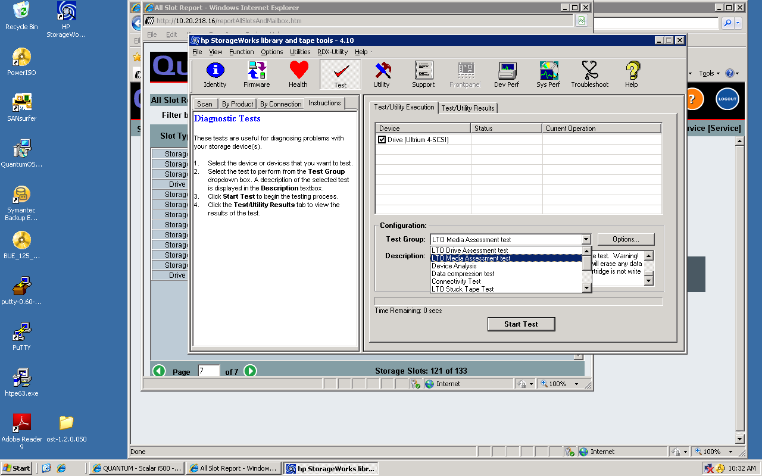

Select “Options…” button. Set the “Allow Overwrite” = TRUE from the “Options…” screen by double clicking the “Allow Overwrite” and selecting “True” from pull down menu.

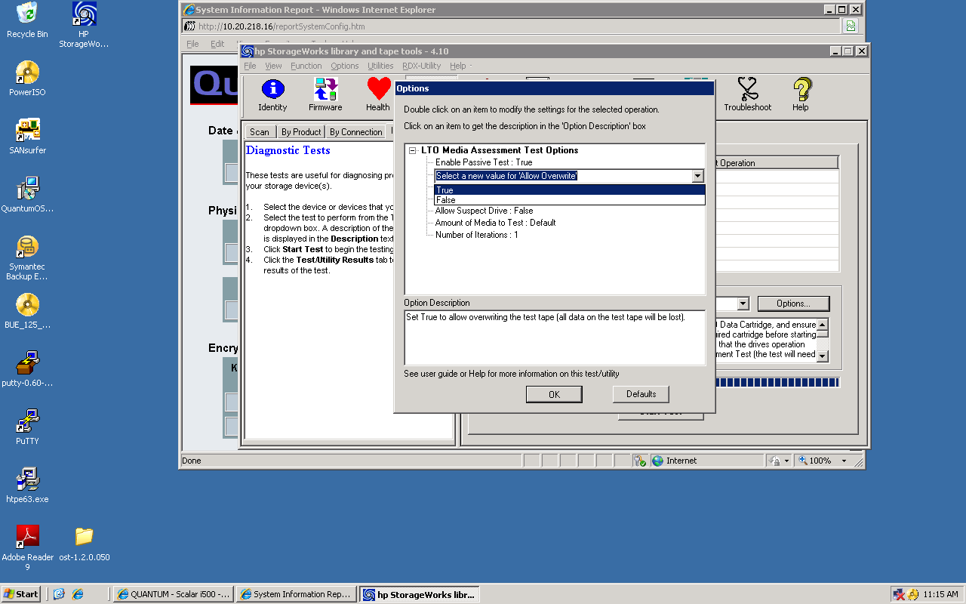

Start Media Assessment Test by clicking the “Start Test” button. Test will complete after 15-20 minutes

Example of FAILED Media Assessment Test

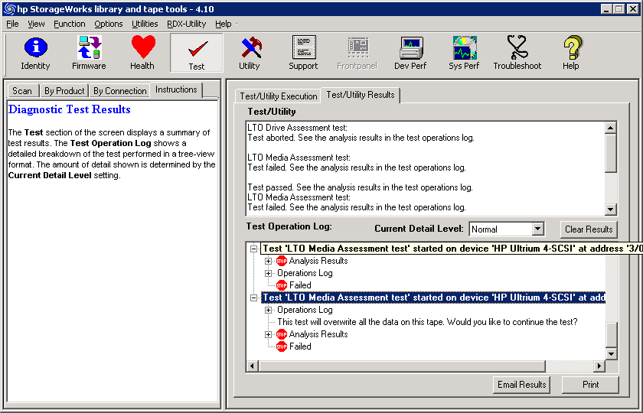

Example of failure (suspect media)
|__ Test 'LTO Media Assessment test' started on device 'HP Ultrium 4-SCSI' at address '3/0.0.2'
||__ Analysis Results
| ||__ LTO Media Assessment Test, version V03.03.2010
| ||__ Test run: Mon May 10 11:14:29 2010
| ||__ TEST TYPE: Read Only (Backup Assessment).
| ||__ To perform the full Media Assessment Test, please set the ‘Allow overwrite’
| ||__ test option to TRUE and re-start the test.
| ||__ The ‘Allow overwrite’ test option was set to FALSE.
| ||__ Therefore the test can only assess the quality of the data already backed up on
| ||__ the data cartridge, and not the quality of the media.
| ||__ Warning! Running the test with the ‘Allow overwrite’ test option set will erase any
| ||__ data already on your data cartridge.
| ||__ ’Allow suspect drive’ test option: FALSE
| ||__ Drive Assessment Test last run: 0:00:52:48 Power on (Days:hours:mins:secs) ago
| ||__ Drive Assessment Test result (from last run): Passed
| ||__ Test options (from last Assessment Test run): Default options were used
| ||__ Drive margin (from last Assessment Test run): 100%
| ||__ MEDIA IDENTITY/CONFIGURATION:
| ||__ Vendor: FUJIFILM
| ||__ Format: LTO-4
| ||__ Capacity: 799 GB (native) 1.6 TB (assuming 2:1 compression)
| ||__ Serial Number: 074E103607
| ||__ Barcode: Unknown
| ||__ Manufactured: May 12 2007
| ||__ ANALYSIS OF HISTORICAL INFORMATION (from drive logs)
| ||__ [Please check the Support Ticket for full details.]
| ||__ Media Health
| ||__ Data on tape: Not enough data
| ||__ Drive measurements: Great margin
| ||__ Write/read life: Great margin
| ||__ Load/unload life: Great margin
| ||__ Media Environment
| ||__ Maximum temperature has not been exceeded in the last 3 drives.
| ||__ RESULTS OF TESTS ON THIS MEDIA
| ||__ Amount of data required’ test option : Default
| ||__ Verify command failed after reading 0 MB
| ||__ Byte2 0x5 SenseCode 0x20 SenseQual 0x0 ErrorCode 0x0

| ||__ The drive failed to read the data from the data cartridge.
| ||__ The integrity of the data on this data cartridge cannot be guaranteed.
| ||__ Please run the LTO Drive Assessment Test to check the operation of the
| ||__ drive that was used to perform this backup operation.
| ||__ You are recommended to repeat the backup operation.
| ||__ To fully test this Data Cartridge, the Full Media Assessment Test should be run.
| ||__ See the information above on how to run the full test.
| ||__ Note: The drive is working well, as it has recently passed the LTO Drive Assessment Test with excellent margin.
| ||__ Iteration number: 1 of 1
| ||__ Data requested (native): 28.5 GB Data read (native): 0 KB
| ||__ Testing has completed and some problems were found.
||__ Operations Log
| ||__ executing LTO Media Assessment Test...
| ||__ checking tape load ...
| ||__ rewinding ...
| ||__ LTO Media Assessment Test Finished...
| ||__ Test failed
||__ Failed

Example of Successful Media Assessment Test

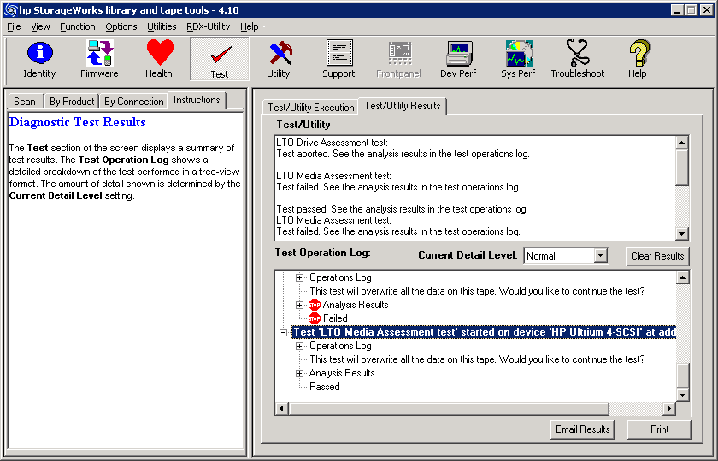

|__ Test 'LTO Media Assessment test' started on device 'HP Ultrium 4-SCSI' at address '3/0.0.2'
|__ Operations Log
| |__ LTO Media Assessment Test Options
| |__ Enable Passive Test : True
| |__ Allow Overwrite : True
| |__ Check WORM Integrity : True
| |__ Ignore Cleaning Requests : False
| |__ Allow Suspect Drive : False
| |__ Amount of Media to Test : Default
| |__ Number of Iterations : 1
| |__ executing LTO Media Assessment Test...
| |__ checking tape load ...
| |__ erasing ...
| |__ soft unload ...
| |__ loading ...
| |__ writing wrap 4 ...
| |__ writing top wrap ...
| |__ writing bottom wrap ...
| |__ soft unload ...
| |__ loading ...
| |__ erasing ...
| |__ rewinding ...
| |__ LTO Media Assessment Test Finished...
| |__ Test Passed.
|__ This test will overwrite all the data on this tape. Would you like to continue the test?
|__ Analysis Results
| |__ LTO Media Assessment Test, version V03.03.2010
| |__ Test run: Mon May 10 12:12:24 2010
| |__ TEST TYPE: Overwrite.
| |__ ’Allow suspect drive’ test option: FALSE
| |__ Drive Assessment Test last run: 0:01:48:31 Power on (Days:hours:mins:secs) ago
| |__ Drive Assessment Test result (from last run): Passed
| |__ Test options (from last Assessment Test run): Default options were used
| |__ Drive margin (from last Assessment Test run): 100%
| |__ MEDIA IDENTITY/CONFIGURATION:
| |__ Vendor: FUJIFILM
| |__ Format: LTO-4
| |__ Capacity: 799 GB (native) 1.6 TB (assuming 2:1 compression)
| |__ Serial Number: 076H115292
| |__ Barcode: Unknown
| |__ Manufactured: July 01 2007
| |__ ANALYSIS OF HISTORICAL INFORMATION (from drive logs)
| |__ [Please check the Support Ticket for full details.]
| |__ Media Health
| |__ Data on tape: Not enough data
| |__ Drive measurements: Great margin
| |__ Write/read life: Great margin
| |__ Load/unload life: Great margin
| |__ Media Environment
| |__ Maximum temperature has not been exceeded in the last 3 drives.
| |__ RESULTS OF TESTS ON THIS MEDIA
| |__ [Please Note: the operations performed by this overwrite test will NOT be
| |__ reflected in the Support Ticket usage/health information.]
| |__ Amount of data required’ test option : Default
| |__ Iteration number: 1 of 1
| |__ Overall Margin: Great margin (41.6 GB written)
| |__ The LTO Media Assessment Test completed successfully.
|__ Passed

4). Gathering device “Support Ticket” (a.k.a Drive log)

Once the tests have completed, gather a device “Support Ticket” from the tape drive

Device Support Ticket Steps:

4a). Select the “Health” icon or pull down menu option from the GUI.

4b). Once complete, select “Current Detail Level” to “Everything” and from the “File” pull down menu “Save As” file for packaging to Engineering. Use an intuitive filename that clearly identifies the log with the respective drive Serial number, date/time and event as needed.

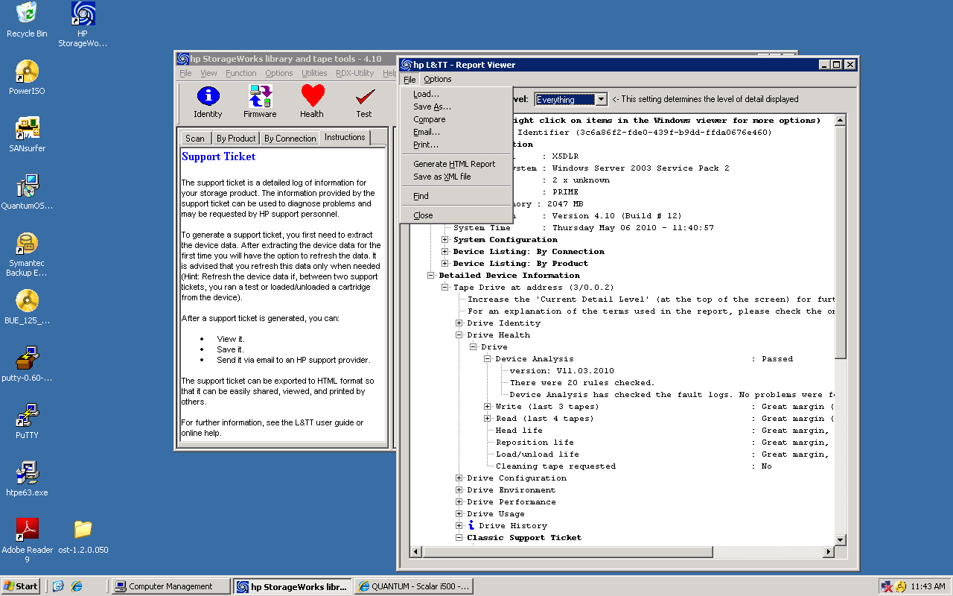

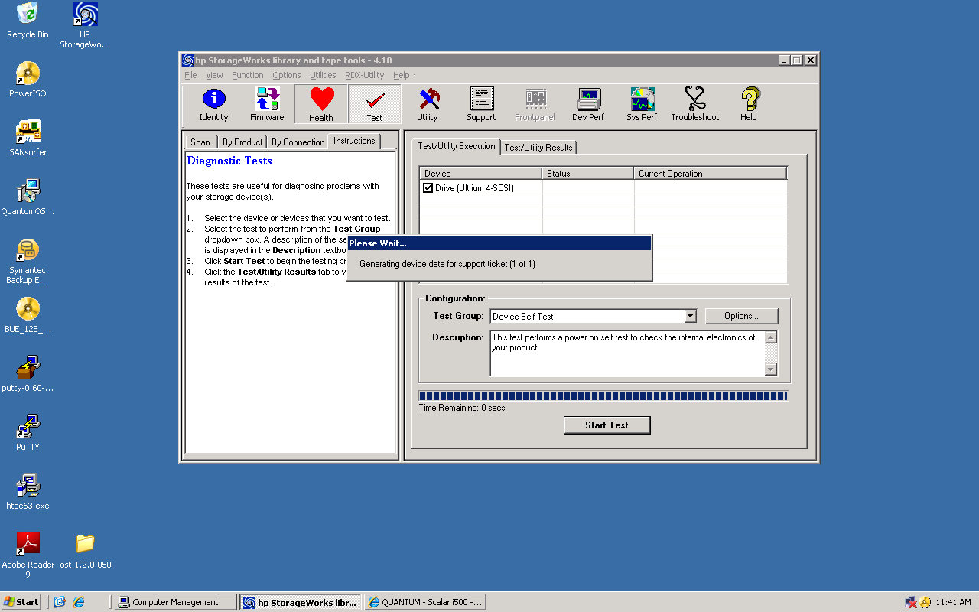
5). Forward the Support Ticket files to the respective escalation path contacts, drive log email aliases and reference them in the SR.

