HP Dexlite usage for gathering HP LTO drive log captures

Purpose:

This documents usage of the HP Dexlite utility for gathering drive logs in a typical HP LTO deployment.

Prerequisites:

1). The host system requires access to tape drives with valid device drivers installed
2). Dexlite utility installed.

Obtain the HP Dexlite Util from the drive Eng Team or your respective escalation path.

NOTE: This Util is not for published by HP for distribution
NOTE: Drive Eng may request Dexlite logs in addition to those pulled from LTT/Library
NOTE: Dexlite is a Windows Utility only
NOTE: Dexlite can be used to gather drive logs via the serial port interface (Eng Cable required with Engineering Guidance required-TBD)

Procedure:

1). Initialize the Dexlite utility via clicking the executable file. Select the “SCSI (tape drives), id” button and enter the Tape Drive ID if connecting from a host Windows server with drive access.

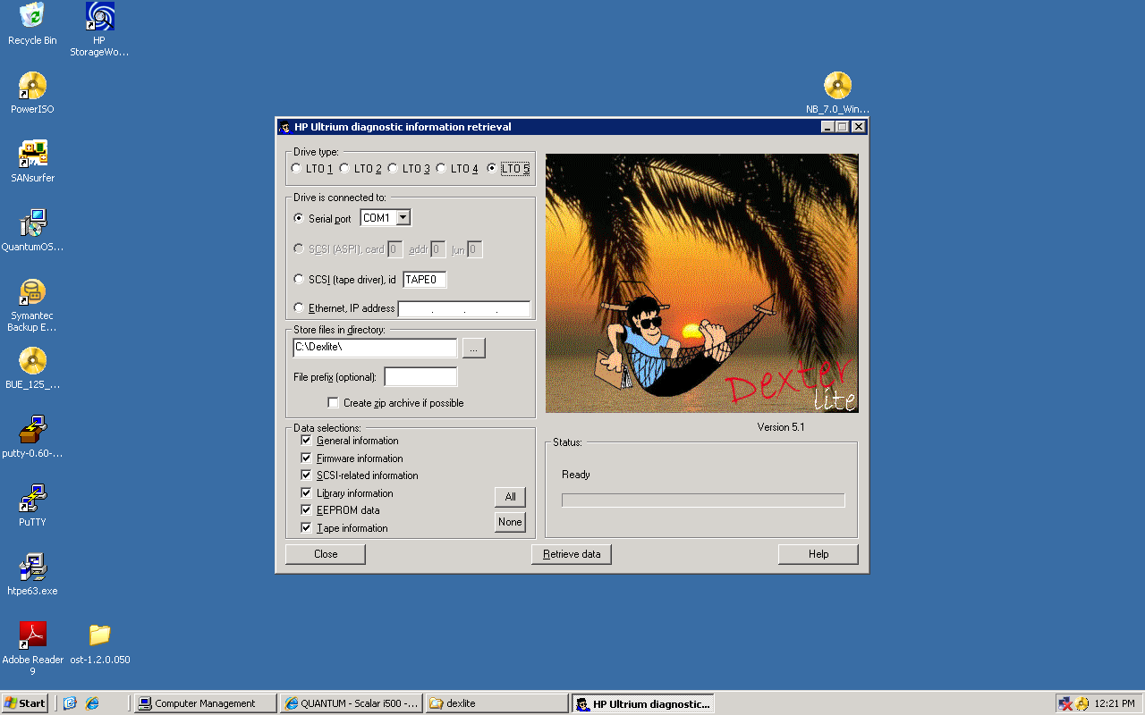

NOTE: The Tape Drive ID can be obtained by right clicking the properties page from Windows Device manager and viewing the “Tape Symbolic Name” tab.

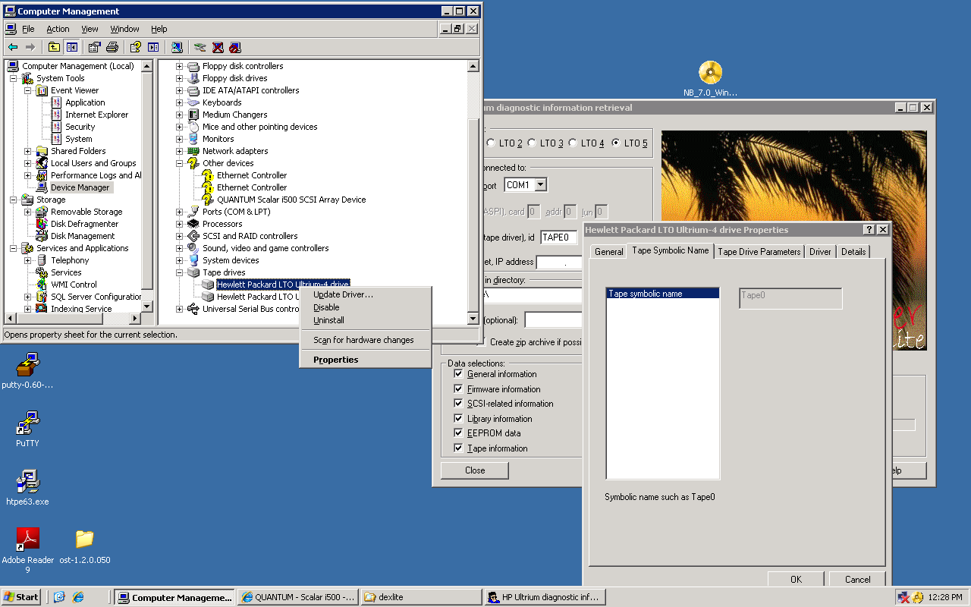

2). Select the appropriate checkbox from the “Drive type” box in the GUI.

3). Enter/Note the destination folder for the saved files in the “Store files in directory” field of the GUI

3). Enable all checkboxes in the “Data Selections” box of the GUI and select “Retrieve Data”

NOTE: An error may appear complaining about a problem reading Cartidge Memory Chip if gathering a drive log from a drive that is not loaded with a tape.

4). Save and Forward the resulting file to the respective escalation path contacts, drive log email aliases and reference them in the SR. Use an intuitive filename that clearly identifies the log with the respective drive Serial number, date/time and event as needed.

