Optimizing Data Transfer Speed
with the Quantum DAT 72 SATA Tape Drive

Your DAT 72 SATA tape drive is capable of transferring data using Ultra DMA mode (UDMA) data transfer protocol. If the DAT 72 SATA Driver will not be installed, it is possible that the host may configure the DAT 72 drive for PIO data transfer speeds. This will result in slower data transfer. This may occur if all of the following conditions are true for a system:

1) The operating system is a Microsoft Windows environment.
2) The system has never had a Quantum DAT 72 SATA tape driver installed previously.
3) The Quantum DAT 72 SATA tape drive is connected to the system via an Intel
Motherboard containing an Intel I/O Controller Hub ICH5, ICH6 or ICH7 or a Motherboard with an Intel compliant I/O Controller Hub ICH5, ICH6 or ICH7.

The instructions below detail how to configure DAT 72 SATA for UDMA transfer speed when the DAT 72 SATA Driver is not installed or another Backup Software Application driver is used instead of the Quantum DAT 72 driver.

Right click on My Computer on your desktop, left click on Manage, and then click on Device Manager to launch the Device Manager dialog Box.
Choose the View menu option, and then Devices by Connection (Fig 1).

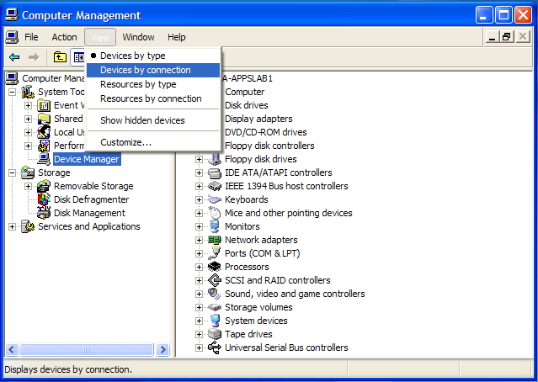

Figure 1
Now, using the mouse, please expand the following categories in the order listed to see the following dialog box.

1. ACPI Uniprocessor PC or ACPI Multiprocessor PC
2. Microsoft ACPI-Compliant System
3. PCI Bus
4. Intel(R) XXXXX Serial ATA Storage Controllers
5. Primary IDE Channel and Secondary IDE Channel

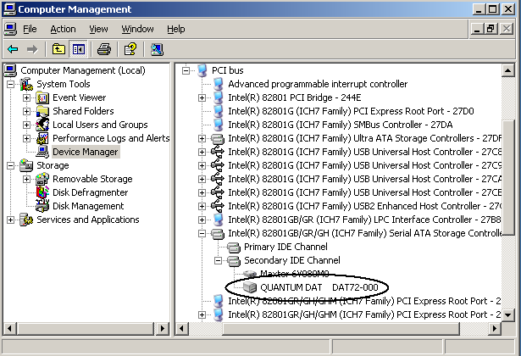

Figure 2

If the DAT 72 SATA shows up in the Device Manager classified under Intel(R) XXXXX Serial/Ultra ATA Storage Controllers, then it is true that the DAT 72 SATA is connected to the system via a SATA connection that is an Intel compliant I/O Controller Hub ICH5, ICH6 or ICH7.

To configure the host, begin by finding the DAT 72 SATA in the previous screen and right clicking the mouse over "QUANTUM DAT 72"; then click Properties to get the screen shown in Figure 3 below.

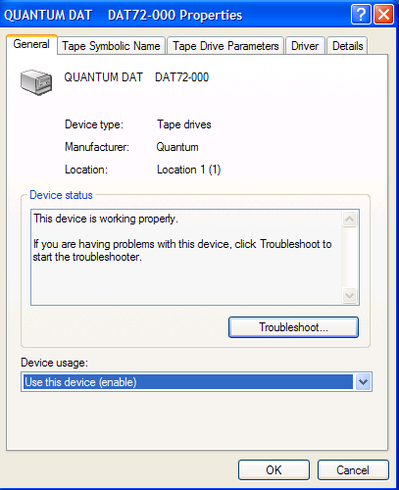

Figure 3

Note the line, "Location: Location 1 (1)". Yours may show, "Location 0 (0)". Click OK and then right click on either the Primary IDE Channel or the Secondary IDE Channel as is appropriate for where you see "QUANTUM DAT 72 on your system (see the Device Manager screen above as an example).

Next, click on Properties and then click on the Advanced Settings tab. You will see a screen similar to Figure 4.

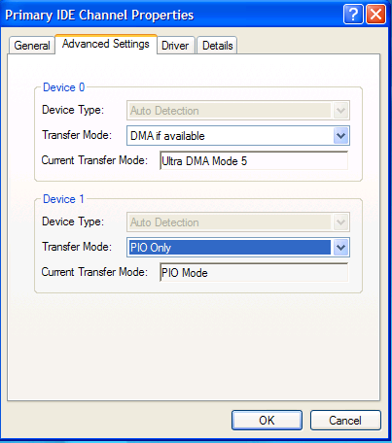

Figure 4

Recall the screen, "QUANTUM DAT 72 Properties" from above and the "Location" line. If the Location shows "Location 1 (1)," then the DAT 72 SATA is attached as Device 1 in the "IDE Channel Properties" screen above. If the Location shows "Location 0 (0)," then the DAT 72 SATA is attached as Device 0 in the "IDE Channel Properties" screen above. In our example above, DAT 72 SATA is attached as Device 1, the Transfer Mode is "PIO Only" and the Current Transfer Mode is "PIO Mode".

You can change this transfer mode to UDMA by clicking on Transfer Mode and choosing "DMA if available" as shown in Figure 5 below.

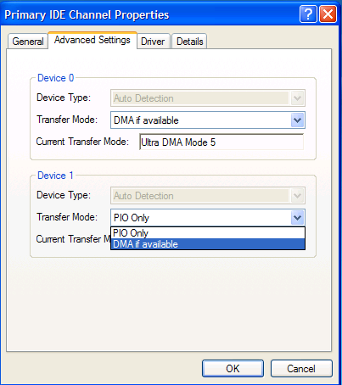

Figure 5

Click OK and then close all open windows and reboot the system. When the system comes up and Windows is started, you should be able to follow the previous instructions to find the window above. The window should now look like the one in Figure 6.
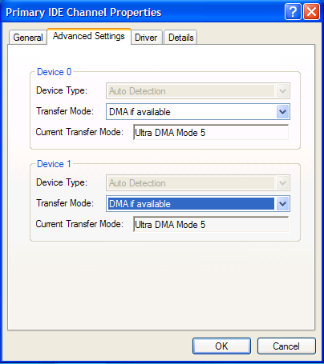

Figure 6

(Note that Windows 2000 may only show "Ultra DMA Mode".)

The DAT 72 SATA will operate in UDMA data transfer modes.

